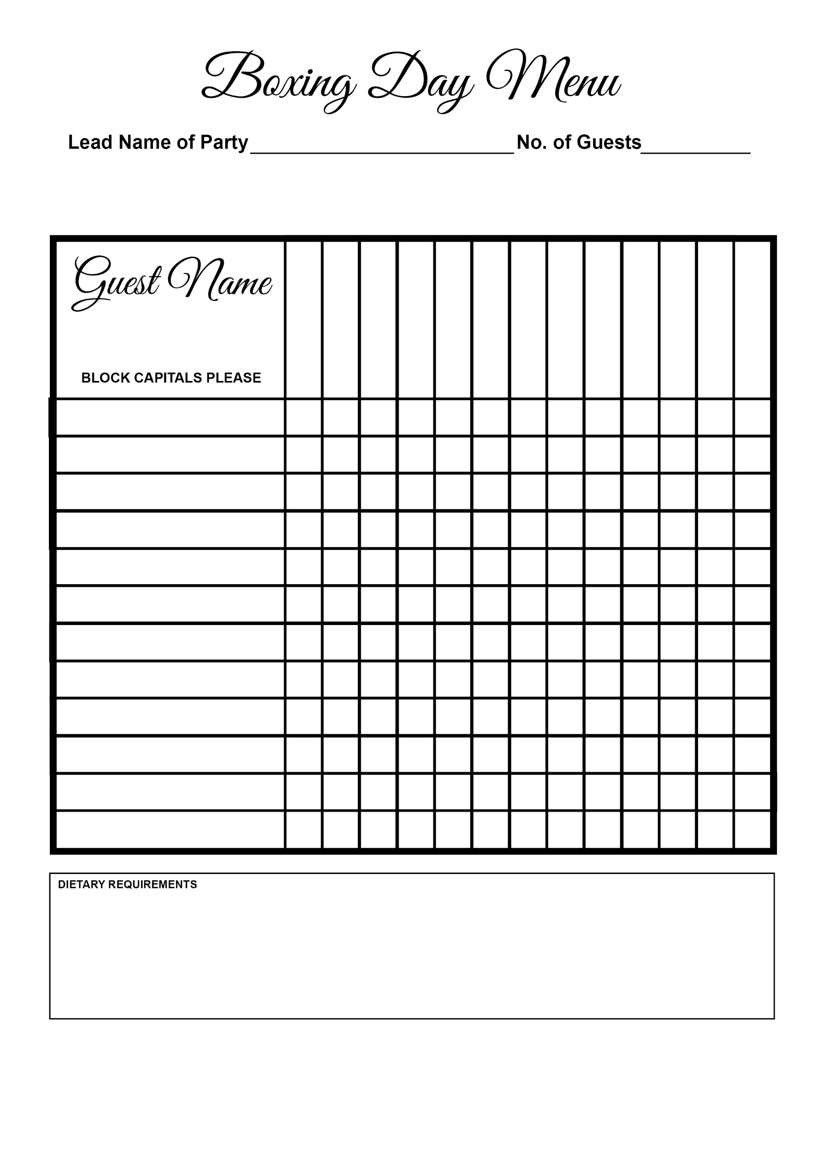



Venison Casserole

Apple Strudel

Smoked Haddock

Fruit Trifle

Cheeseboard

Roulade

Tagliatelle

Cod

Gammon

Deep Fried Brie

Pate

Soup