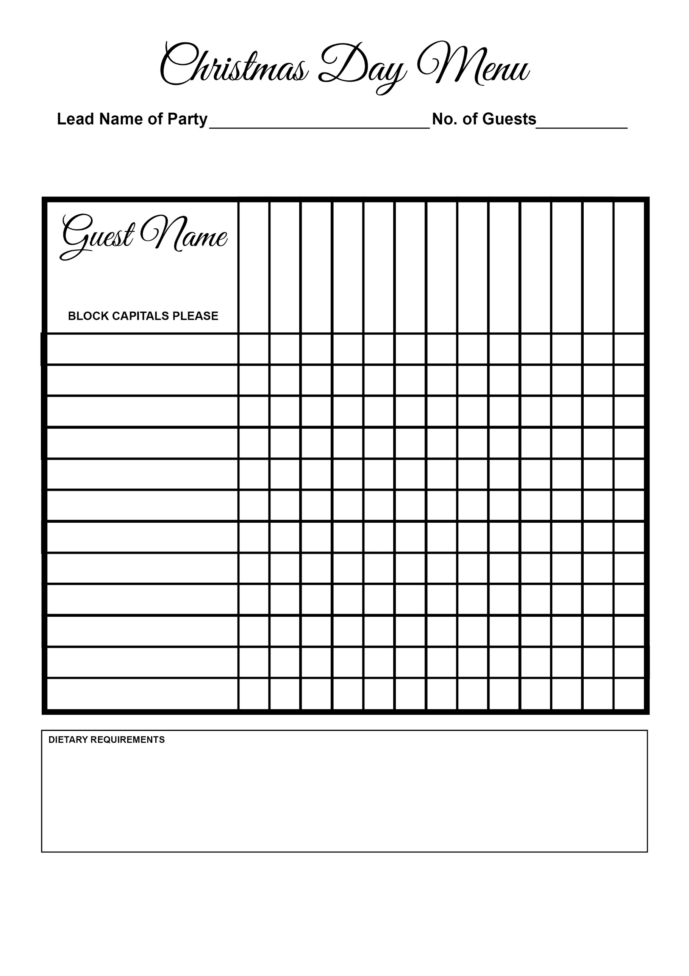

Chocolate Fondant

Cheeseboard

Figgy Pudding

Lamb

Citron Tart

Goat’s Cheese

Salmon

Turkey

Sorbet

Salmon Gravlax

Stilton Rarebit

Rabbit Ravioli

Soup