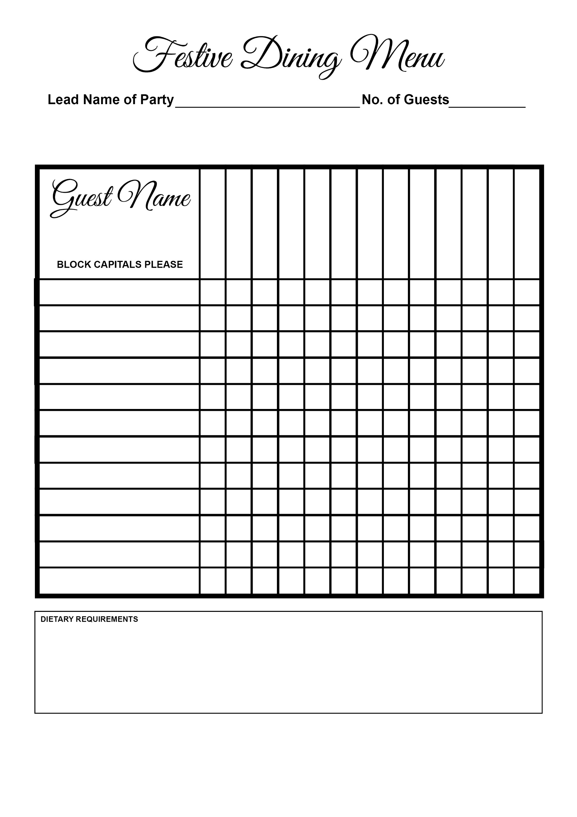

Cheesecake

Christmas Pudding

Profiteroles

Goat’s Cheese

Salmon

Turkey

Pate

Seafood Cocktail

Soup