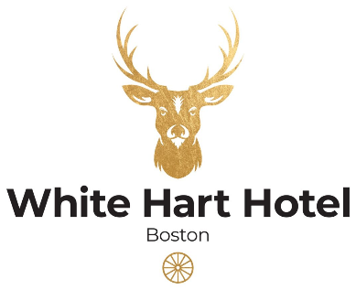

Boxing Day Pre-Order Form
Lead Guest Name: ____________________ Date of Booking: 26th December 2023
Number of Guest: _____________________ Time of Booking:______________________
 | STARTER |  |  |  |  |  | MAIN |  |  |  |  |  | DESSERT
GUEST NAME | Roasted tomato & red pepper soup | Ham hock, herb & pea terrine | Chicken liver parfait, | Cheddar cheese soufflé, | Smoked haddock fishcake, | Mushroom & chestnut pâté, | Honey mustard roast gammon | Roast topside of beef | Chicken supreme, | Fish & chips | Fillet of chalk stream trout | Root vegetable & lentil wellington, | Chocolate orange mousse | Vegan chocolate tart, | Classic crème brûlée, | Vanilla panna cotta | Apple tart, | Selection of ice cream & sorbets | ALLERGIES/DIETARY REQUIREMENTS

